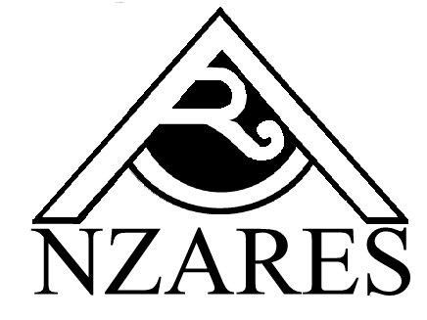
President’s Report 2007

It is my pleasure to present my report on another successful year for NZARES. The highlight was hosting the AARES conference in Queenstown, where Professor Allan Rae of Massey University became AARES President.

Another highlight was the ability of members to attend the International Association of Agricultural Economists conference on the Contributions of Agricultural Economists to Critical Policy Issues that was held at Gold Coast, Australia, 12-18 August 2006.

51st AARES conference

The 51st AARES conference was held in Queenstown on the 13-16 February with two preconference workshops held. Over 200 people attended.

The conference theme was Australasia’s Resource –Based Industries in a Future World. A strong list of local and international invited speakers contributed to the success of the conference with the Sir John Crawford Distinguished Fellows address given by Professor GianCarlo Moschini, of Iowa State University.

Around 180 contributed papers were presented in eight concurrent sessions and are located on the AgEcon Search at http://agecon.lib.umn.edu/

Thanks to the local organising committee of Ross Cullen (chair), Katie Bicknell, Rod Forbes, Stuart Ford, Quentin Grafton, Suzi Kerr, Richard Lynch, Allan Rae and Frank Scimgeour. Two people deserve a special mention: Ross Cullen did an outstanding job including helping raise over A$57,000 in sponsorship and Allan Rae for organising the invited speakers. Ross also wrote a conference organiser’s handbook which will assist future organisers.

We are grateful for the sponsors. The final surplus was A$31,800.

2007 Workshop

With hosting the 51st AARES conference we decided not to run a separate NZARES conference. Instead a one day workshop was held in Wellington on 23 August. Thanks to the speakers: Kay Cao, Krishna Iyer, David McCall, Chris Carson, Caroline Saunders, Allan Rae, Hayden Montgomery; Stuart Ford and Kevin Guerin. Topics covered included: productivity, trade and the environment.

Thanks to MAF for again providing the data show and for hosting the President’s shout.

Heading West Awards

Two heading West Awards to foster trans Tasman interchange of ideas were granted. Congratulations to Nick Giera and Kelly Lock.

NZARES Postgraduate awards
Congratulations also to Richard Yao (Waikato University) and Bhagwan Yadav (Lincoln University) winners of NZARES Postgraduate award.

Up Coming Events

52nd AARES Conference

The 52nd Annual AARES Conference will be held in Canberra, ACT from 6 to 8 February, 2008, with pre-conference workshops on 5 February. The deadline for submission of paper titles is 14 September 2007.

ECReW

The 2007 workshop for Early Career Researchers in the area of Environmental and Resource Economics is to be held on 12-13 November 2007, in Bathurst, NSW, Australia. The goal of the workshop is to provide a forum for early career researchers to get feedback on their research, interact with and receive advice from more experienced academics, and to meet other researchers at a similar stage in their research careers.

NZARES finances
The finances of the organisation continue to be healthy. Thanks to Treasurer Phil Journeaux for his continued stewardship of the finances.

NZARES Committee
The NZARES committee has met twice during the past year, once face to face and once by teleconference. My thanks to the committee members.

Richard Lynch
23 August 2007

