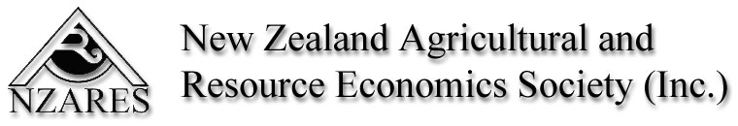

2008 NZARES Conference
Economic Instruments – an idea whose time has come

Thursday 28 and Friday 29 August 2008
Tahuna Conference Centre - Nelson

Keynote Speakers:
- Ralph Townsend – Chief Economist, Ministry of Fisheries
- Alex Sundakov – Executive Director, Castalia
- Julie Collins – Manager of the MAF Climate Change Programme
- Chris O’Donnell – AARES President, Associate Professor, School of Economics, University of Queensland

The conference after dinner speaker is local humorist, cartoonist author and fishing writer - Daryl Crimp

The conference registration form has more detail about the conference.

Abstracts for contributing papers due Friday 27 June 2008
Email to: matthew.newman@dairynz.co.nz

Refer to Style Guide for contributing paper template

